Pear Tree Primary School incorporating Pips Before and
After School Club

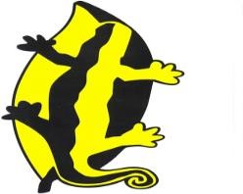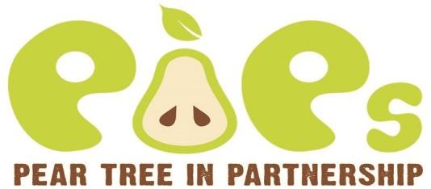

CALCULATION POLICY

Date agreed | September 2023
Date for Review | September 2025
Authors:  Reviewed by: | Matthew Greasby
Signed on behalf of the Governing Board by:  Name: | Signature:  Date:
Signed on behalf of the school by:  Ruth Hadfield  Acting Head Teacher | Signature:  Date:
This policy outlines what we do at Pear Tree School to teach calculation. We support children in order to broaden, deepen and apply their calculation knowledge. Maths is not about number but about life. It is about the world in which we live. It is about ideas. We need to make maths exciting and meaningful for the children we teach.

By teaching mathematics creatively inside and out of the classroom we enable the children to become enthused and interested. This in turn has a positive impact on their mind-set and feelings towards maths.

For each year group, the teacher assesses that the children have understood each process and strategy before moving on to the next stage in their learning. We understand that children learn at different rates and that not all children will be using the same strategy at the same time.
We encourage children to use a range of vocabulary to support their understanding of the process used in calculating. In all the methods of calculation it is important to encourage the children to estimate their answers.
All the time we are also encouraging the use of mental calculation as being able to calculate mentally is an important part of mathematics. Since multiplication and division, addition and subtraction are inverse operations they should be taught alongside each other rather than as separate entities. It is important that children are taught to appreciate and make use of these mathematical relationships when developing and using mental calculation strategies.
As calculations become more complex, written methods become more important. Recording in mathematics and in calculation in particular, is an important tool both for furthering the understanding of ideas and for communicating those ideas to others. A useful written method is one that helps children carry out a calculation and can be understood by others.
At each stage of their learning the children are encouraged to use manipulatives to help support their learning. Once the children become familiar with the different types of manipulatives in their classroom they will then start to take responsibility and choose the most appropriate one to help them with their calculation.

When using or applying calculation strategies children will be encouraged to consider what will be the most efficient and reliable way of doing the calculation:

Can I do this in my head?
Can I do this in my head using drawings or jottings?
Can I get something to support me with this calculation?
Do I need to use a written method?
Do I need a calculator?

Teaching for mastery
Children will learn through teaching for mastery. Maths mastery relies on classroom practice and school organisation to give pupils a deep, long-term, secure and adaptable understanding of maths. Mastery is a long-term, cumulative approach. Maths understanding, knowledge and skills are systematically deepened and built-upon yearly.

All classes will follow the same lesson structure to ensure consistency in teaching and learning:
- Exploration – A whole class investigational type question (this may sometimes form the whole lesson depending on how discussions / learning progresses) This relates to the lesson objective.
- Structure learning – Specific lesson focus using concrete resources and whiteboards.
- Practice and apply – Fluency questions in maths books, both pictorial and abstract
4) Extension / deepening understanding – A chance to prove and explain.

Within the ‘Explorations’, children will work in mixed ability pairings to answer questions. They will draw, show, explain and prove how they have arrived at an answer and will have opportunities to ‘talk maths’.
Questions to prompt thinking before attempting questions are highlighted below:

- What am I trying to find out?
- Have I seen a problem like this before? If so, where and why is it similar?
- What else do I need to know before I get started?
- What strategies or resources could I use to help me?

As a non-negotiable, where appropriate, classes will complete 3 paper sessions of Times Table Rockstars per week. Children will be distributed with logins to the TTRS website and parents will be encouraged to support their child on the use of this at home.
Classes across the school have access to resources that aid in the teaching of arithmetic and reasoning & problem solving questions. All classes follow the White Rose scheme of learning.

Addition

 | Addition
Stages of learning | Examples of what it looks like | Vocabulary
Children are encouraged to develop a mental picture of the number system in their heads to use for calculation. They should experience practical calculation opportunities using a wide variety of equipment, e.g. role play, counters, cubes etc.  Children will begin to count in sets of objects. |  | add more groups  how many
Children begin to combine sets of objects into one group and count practically. | Children may count an initial group then add more objects to that group.
Children will use and draw pictures or symbols to begin solving and recording addition problems. | 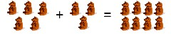
Children will begin to represent groups of objects with numbers to form basic number sentences. | 5+3=8 | total  how many  count on in same as equals more sum  altogether  how many more to make
Children will use a number track to visually support their adding on. | 6+2=8  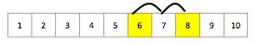
Children begin to cross the tens boundary and are beginning to set their calculations out in a more formal manner. They use number lines, | 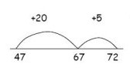 | hundreds tens ones boundaries

hundred squares and other material to visually support their addition. |  | partition  partitioning near doubles strategy running total mental calculations place value
Children begin working with two digit numbers and to record mental methods  using partitioning. It is vital that this stage the children should have a secure knowledge of place value.  Add the tens and then the ones to form partial sums and then add these partial sums.  Partitioning both numbers into tens and ones mirrors the column method where ones are placed under ones and tens under tens. This also links to mental methods.  Partitioned numbers can then be written under one another.  Partitioning is also a very useful strategy when beginning to add 3-digit numbers together.  These stages should be supported using concrete apparatus such as Base 10 (Dienes), leading on to Place Value Counters.  Use place value grids to show the importance of keeping the numbers in the correct columns | Record steps in addition using partitioning:  - 47 + 76 = 123  47 + 70 = 117  117 + 6 = 123  - 47 + 76 = 123  40 + 70 = 110  7 + 6 = 13  110 + 13 (10+3) = 123  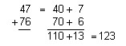

Children continue working with two digit numbers and set their work out using the expanded method in columns, making sure they line their relative place value columns up. They add the ones first and then the tens.  Their understanding of place value can help them to add the final section together mentally.  Number lines, hundred squares and other materials can still be used to visually support the child. | 25  +31  6 -------→ Children have Added the ones  50 -------→ Children have added the tens  56 -------→ Children have added the two parts
Children continue this strategy.  Moving on to bigger numbers such as, three digit plus 2 digit addition or with four digit numbers.  Children may need to add with partitioning more than once to help them add the final number mentally more easily. | 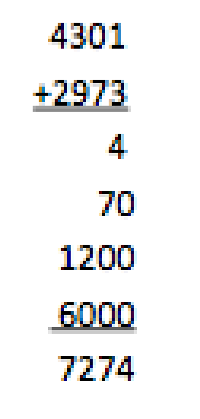 | sum  addition  total altogether rounding partitioning decimals  columns
As a final strategy, children are taught to condense their addition into a single step column method by regrouping the digits which cross the tens / hundreds boundary.  This strategy will help them to add decimal numbers. | 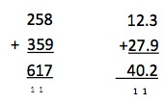 | Regrouping

Subtraction

 | Subtraction
Stages of learning | Examples of what it looks like | Vocabulary
Children begin to practically remove objects from a group and use oral work to begin to understand the concept of subtraction. | Songs, stories and drama will be used for children to act out and represent the subtraction taking place. | take how many left less
Children will draw pictures or symbols and then cross them off to begin solving and recording subtraction problems. | 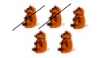
Children will begin to represent subtraction using basic number sentences but can still have the subject of objects. | 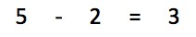 | difference take away subtract less than minus

Children begin to use horizontal number lines to subtract. They will start at the highest number and count back.  They will also use a horizontal number line to find the difference. They will start at the lowest number and count up to the highest number to find the answer.  They will be encouraged to do this mentally from 0-10 and then later from 0-20. | 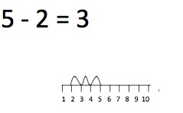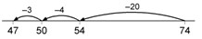 | difference between leaves me with subtract inverse  find the difference less than take-away partition partitioning strategy  count on
Children are beginning to subtract bigger numbers up to 100, recording their work on empty number lines.  They will use the subtraction method of counting back from the biggest number.  This requires children to subtract a single-digit number or a multiple of 10 from a two-digit number mentally. The method of recording links to counting back on the number line. Complementary addition - they will also use a number line to find the difference/How many more? This can be referred to as the process as counting on.  This process uses the inverse operation  From the smallest number, they will jump to the next multiple of 10, then jump in multiples of 10, then add on the ones.  Children will add the jumps together to find their answer. | 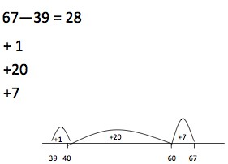

Along with using number lines children will use partitioning to subtract. It’ll be recorded using partitioning to write equivalent calculations that can be carried out mentally.  For 74 - 27 this involves partitioning the 27 into 20 and 7, and then subtracting from 74 the 20 and the 7 in turn.  Some children may need to partition the 74 into 70 + 4 or 60 + 14 to help them carry out the subtraction.  Their understanding of place value can help them to add the final section together mentally.  Partitioning can then become set out in a column formation to get the children ready for column subtraction – decomposition method.  As with addition, subtraction methods should be supported by the use of concrete resources throughout | Subtraction can be recorded using partitioning:  74 - 27 =  74 - 20 = 54  54 - 7 = 47  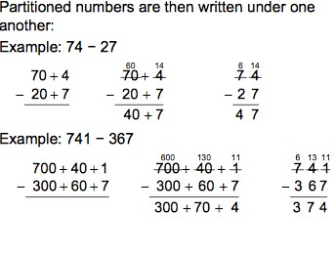
Children continue to develop their use of the number line for all subtraction work, including larger numbers and decimals.  If they are ready to move on they begin to use the subtraction column method.  Children should be confident in their ability to add when using this method.  Finally, children are introduced to the decomposition method of column subtraction.  For the subtraction 653 – 335, you cannot subtract 5 ones from 3, therefore we exchange a ten from the 50 to add to the 3 ones to make 13 ones. Then the subtraction can continue as normal. | 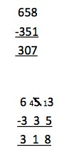 | Exchange

N.B. These steps focus on the transition from concrete resources, through pictorial before focusing on abstract calculations.

Multiplication

 | Multiplication
Stages of learning | Examples of what it looks like | Vocabulary
Children will begin the process of multiplication by counting in groups or patterns in an informal or practical manner. |  | sets of groups

Children develop their concept of multiplication as grouping. | 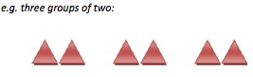 | pattern groups addition lots of
Children will reinforce their concept of multiplication as repeated addition:  5 times 3 is 5 + 5 + 5 = 15 or 3 lots of 5 or 5 x 3  They may use something like a number line to visually support their repeated addition. | 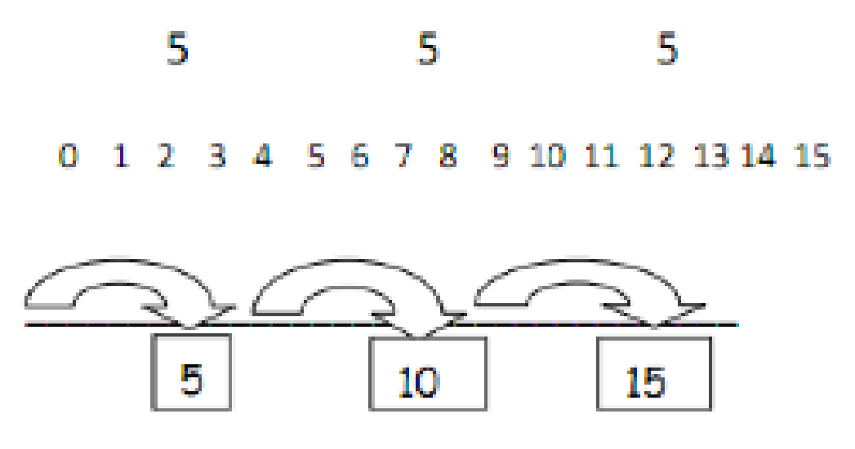 | repeated addition calculate inverse operation  multiply
Children will begin to use arrays to solve simple multiplication calculations and will write these as a number sentence.  They will begin to understand that multiplication can be done in any order  (commutative) | 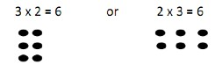 | arrays inverse equivalent  lots of  commutative
Children will learn to use the grid method to solve multiplication calculations.  Children will partition numbers to multiply. They will use their understanding of place value to multiply multiples of 10.  This strategy will be used for all multiplication, including decimal numbers. Children may | 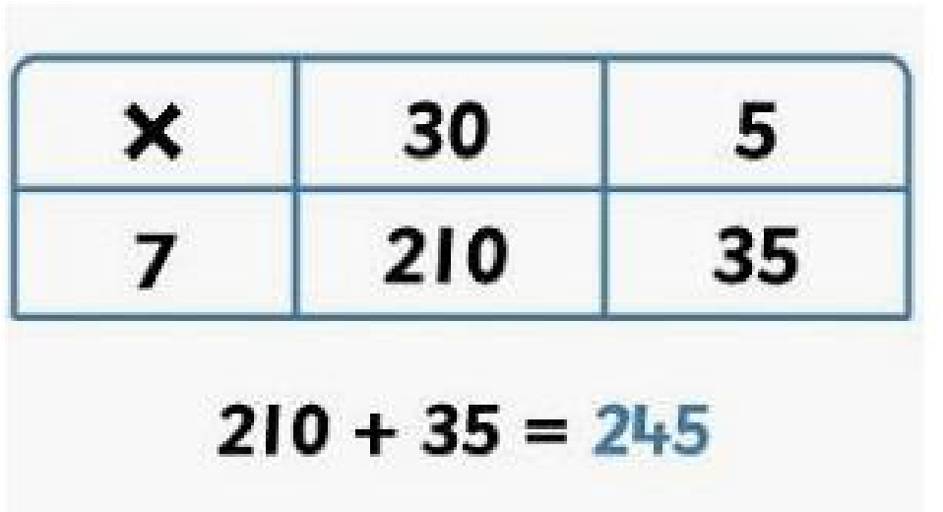 | grid  partition  hundreds tens ones

need to write a separate addition calculation if their grids extend beyond a single column. | For larger multiplication  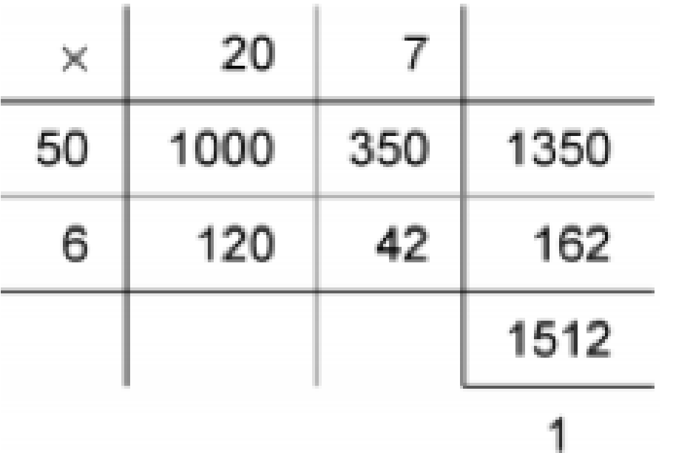
Children will then be introduced to the expanded method of multiplication. This is only introduced when the children are confident with the grid method. | Vertical expanded version for multiplication by ones:  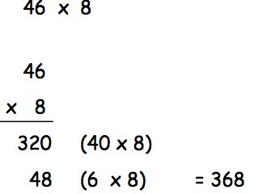 | arrays inverse equivalent  lots of
Children will finally move onto the more efficient compact method of multiplication. Having gone through all of the above stages, children are confident with long multiplication. |  | Thousands  Hundreds  Tens  Ones

These methods can be further developed by using bigger numbers (long multiplication) and decimals.  Examples of long multiplication  Children will then be introduced to the expanded method of multiplication. This is only introduced when the children are confident with the TO X O | Vertical compa  multiplication by o e.g. 46 x 8  46 x 8  Expanded method of lon  Expanded version |  | ct version for nes:  g multiplication
 | 286   29  4000  1600  120  1800  720  54  8294  1 | 2002  802  62  200  80  6 | 0  4000  0  1600  0  120  9  1800  9  720  9  54
 | Compact version  286   29  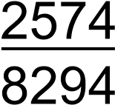  5720  1 |  |  | 28620 286 9
 | 56  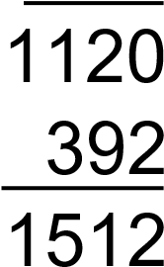   27  1 |  |  | 5620 56 7

Division

 | Division
Stages of learning | Examples of what it looks like | Vocabulary
Children will begin the process of division by sharing and grouping in an informal or practical manner. |  | sets of groups
Children will begin to record their ideas using informal jottings to demonstrate either grouping or sharing. | 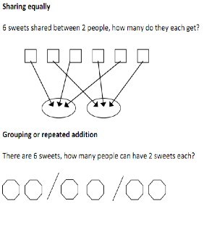 | sharing grouping shared between groups of how many?

Children will relate division and multiplication facts describing them as being the inverse of each other. Arrays may be used to demonstrate this. | 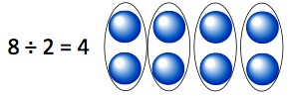 | arrays lots of sharing groups inverse
Children will begin to use a number line to demonstrate division as repeated subtraction. They will initially use a numbered line and count down in the jumps to see how many ‘lots of’ that number there are. | 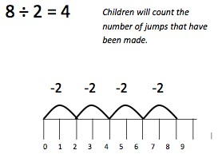 | lots of number line groups of dividing  repeated subtraction
Children will use an empty number line to take out bigger chunks when dividing bigger numbers.  Children may need to use a separate subtraction calculation to support their repeated subtraction. |  | chunks  dividing lots of groups of chunking

 | 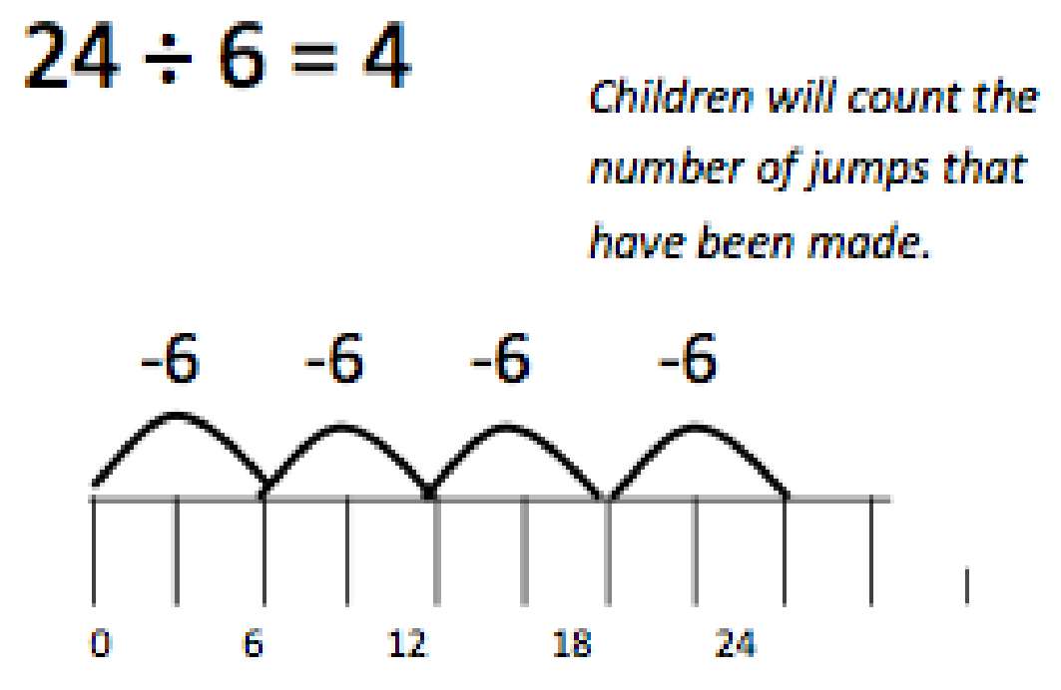
Children will develop their division number line work into the number line chunking method, taking out chunks of a number that you are dividing by.  Children will use this for numbers going over ten times the divisor. | 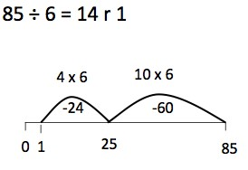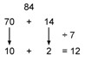  In this example, using  knowledge of multiples, the 84  is partitioned into 70 (the  highest multiple of 7 that is  also a multiple of 10 and less

Children will also be taught and practise a number of mental division strategies using partitioning. | than 84) plus 14 and then each part is divided separately using the distributive law.  Another way to record is in a grid, with links to the grid method of multiplication.  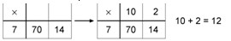  As the mental method is recorded, ask: 'How many sevens in seventy?' and: 'How many sevens in fourteen?'  Also record mental division using partitioning:  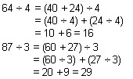  Remainders after division can be recorded similarly.  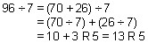

Children will condense the number line chunking strategy into a more efficient written method. To be able to master these methods effectively, children need to be able to multiply a single digit by any multiple of 10 in their head. | ‘Expanded’ method for TO ÷ O and HTO ÷ O  Short division of TO ÷ O by chunking multiples of the devisor. 72 ÷ 3 = 24  3 72  - 30 (10 x 3)  42 - 30 (10 x 3)  12  - 6 (2 x 3)  6  6 (2 x 3)  0  Answer = 24  Short division of HTO ÷ O by chunking multiples of the devisor.  196 ÷ 6 = 32 r 4  6 196  - 180 (30 x 6)  16  - 12 (2 x 6)  4  Answer = 32 r 4 | chunks  dividing  lots of groups of multiples thousands hundreds tens ones

Short hand division methods (bus stop method) are also introduced at this stage.  These methods can be further developed by using bigger numbers and decimals (you can express decimals as fractions). | 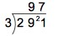  Any remainders should be shown as fractions, i.e. if the children were dividing 32 by 10, the answer should be shown as 3 ²/₁₀ which could then be written as 3 ¹/₅ in its lowest terms.  Extend to decimals with up to two decimal places. Children should know that decimal points line up under each other. |  | Bus Stop Method
Long division  The next step is to tackle HTO ÷ TO using chunking.  Another method of long division using bus stop method.  These methods can be further developed by using bigger numbers and decimals (you can express decimals as fractions). | 87.5  7 | ÷ 7 = 12.5  87.5  - 70.0 (10 x 7)  17.5  - 14.0 (2 x 7)  3.5  - 3.5 (0.5 x 7)  0 Answer = 12.5  