**Year 3**

**PROMPT sheet**

**3/1 Count in multiples**

Now you must learn these multiples

|  |  |  |  |
| --- | --- | --- | --- |
| **Multiples of 4** | **Multiples of 8** | **Multiples of 50** | **Multiples of 100** |
| **0** | **0** | **0** | **0** |
| **4** | **8** | **50** | **100** |
| **8** | **16** | **100** | **200** |
| **12** | **24** | **150** | **300** |
| **16** | **32** | **200** | **400** |
| **20** | **40** | **250** | **500** |
| **24** | **48** | **300** | **600** |
| **28** | **56** | **350** | **700** |
| **32** | **64** | **400** | **800** |
| **36** | **72** | **450** | **900** |
| **40** | **80** | **500** | **1000** |

|  |  |  |
| --- | --- | --- |
| hundreds | **tens** | units |
| 3 | **5** | 2 |

* To find 10 more or 10 less,

it is the ‘tens digit’ that changes

10 more than 3**5**2 becomes 3**6**2

10 less than 3**5**2 becomes 3**4**2

|  |  |  |
| --- | --- | --- |
| **hundreds** | tens | units |
| **3** | 5 | 2 |

* To find 100 more or 100 less,

it is the ‘hundreds’ digit that changes

100 more than **3**52 becomes **4**52

100 less than **3**52 becomes **2**52

**3/2 Recognise place value**

|  |  |  |
| --- | --- | --- |
| **hundreds** | **tens** | **units** |
| **3** | **5** | **2** |

**352** means **300** + **50** + **2**

**3/3 Numbers in words and figures**

In order to put FIGURES into WORDS, we must try to imagine that the number is in a PLACE VALUE table like this one

|  |  |  |
| --- | --- | --- |
| **Hundred** | **Ten** | **Unit** |
| 1 | 4 | 7 |
| One hundred | forty | seven |
| One hundred and forty-seven | | |

|  |  |  |
| --- | --- | --- |
| **Hundred** | **Ten** | **Unit** |
| 4 | 0 | 9 |
| Four hundred |  | nine |
| Four hundred and nine | | |

**3/3 Compare and order numbers**

* Write numbers lining up the digits

|  |  |  |
| --- | --- | --- |
| **Hundred** | **Ten** | **Unit** |
| 1 | 4 | 7 |
| 6 | 3 | 2 |
| 1 | 7 | 6 |
| 1 | 6 | 2 |

* Begin at the hundreds and compare

632 is the biggest

|  |  |  |
| --- | --- | --- |
| **Hundred** | **Ten** | **Unit** |
| 1 | 4 | 7 |
| 6 | 3 | 2 |
| 1 | 7 | 6 |
| 1 | 6 | 2 |

* Move to the tens and compare

**Order is: 632, 176, 162, 147**

**3/4 Estimating**

* **Eyeball estimate**

Here are 10 stars

**Use this to estimate larger quantities**



* **Estimate by sampling**

**Count your pulse over 15seconds**

**Multiply the number of pulses by 4 to get the pulse rate over 1 minute (15 x 4 = 60seconds)**

* **Estimate on a number line**

**Fill in the half way number first**

**Then split up the half with the arrow**

17

**10 20**

**15 16 17 18 19**

73

**0 100**

**50 60 70 80 90**

* **Estimate by rounding off a number**

**To make a sum easier and give a rough answer**

**Example: 28 could be rounded to 30**

**£1.95 could be rounded to £2**

**3/5 Solve problems by estimating**

Example: Estimate the cost of 5

magazines at £1.95 each

Answer: It is about 5 x £2 = £10

Example: When full this bottle holds 400ml.

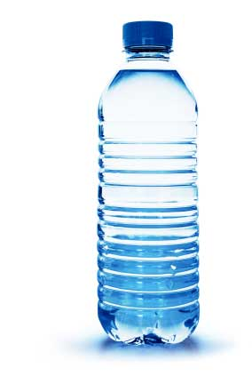Estimate how much water is left in this bottle.

400ml

.............?

Answer: about 150ml

**3/6 Add 3 digit numbers mentally**

Partitioning

**236 + 319**

**200 + 30 + 6 + 300 + 10 + 9**

**= 500 + 40 + 15**

**= 555**

**Subtract 3 digit numbers mentally**

**363 - 126**

Partitioning Counting on from 126

**363 – 100 – 20 – 6 (126) + 4**

**=263 – 20 – 6 130 + 3**

**=243-6 133 + 230**

**=237 =363**

**Answer = 237**

**3/7 Written method for addition**

* **Line up the digits in the correct columns**

e.g. 132 + 239 H T U

1 3 2

2 31 9 +

3 7 1

**Written method for subtraction**

* **Line up the digits in the correct columns**

e.g. 327 - 119 H T U

3 12 17

1 1 9 -

2 0 8

**3/8 Estimate answers to calculations**

* Round off each number
* Then do the calculation
* Check using the inverse

Example: Estimate 83 – 28

80 – 30 = 50

Inverse: 50 + 30 = 80http://ramyasspace.files.wordpress.com/2011/06/tick.jpg

**3/9 Missing number problems**

**Fact family for +/-**

34 + 23 = 57 57 - 23 = 34

23 + 34 = 57 57 – 34 = 23

**3/10 Know the 3, 4 and 8 times tables**

|  |  |  |  |  |
| --- | --- | --- | --- | --- |
| 1 | x | 3 | = | 3 |
| 2 | x | 3 | = | 6 |
| 3 | x | 3 | = | 9 |
| 4 | x | 3 | = | 12 |
| 5 | x | 3 | = | 15 |
| 6 | x | 3 | = | 18 |
| 7 | x | 3 | = | 21 |
| 8 | x | 3 | = | 24 |
| 9 | x | 3 | = | 27 |
| 10 | x | 3 | = | 30 |
| 11 | x | 3 | = | 33 |
| 12 | x | 3 | = | 36 |

|  |  |  |  |  |
| --- | --- | --- | --- | --- |
| 1 | x | 4 | = | 4 |
| 2 | x | 4 | = | 8 |
| 3 | x | 4 | = | 12 |
| 4 | x | 4 | = | 16 |
| 5 | x | 4 | = | 20 |
| 6 | x | 4 | = | 24 |
| 7 | x | 4 | = | 28 |
| 8 | x | 4 | = | 32 |
| 9 | x | 4 | = | 36 |
| 10 | x | 4 | = | 40 |
| 11 | x | 4 | = | 44 |
| 12 | x | 4 | = | 48 |

|  |  |  |  |  |
| --- | --- | --- | --- | --- |
| 1 | x | 8 | = | 8 |
| 2 | x | 8 | = | 16 |
| 3 | x | 8 | = | 24 |
| 4 | x | 8 | = | 32 |
| 5 | x | 8 | = | 40 |
| 6 | x | 8 | = | 48 |
| 7 | x | 8 | = | 56 |
| 8 | x | 8 | = | 64 |
| 9 | x | 8 | = | 72 |
| 10 | x | 8 | = | 80 |
| 11 | x | 8 | = | 88 |
| 12 | x | 8 | = | 96 |

**Fact family for x/÷**

9 x 8 = 72 72 ÷ 9 = 8

8 x 9 = 72 72 ÷ 8 = 9

**3/11 Multiply & divide**

* **A 2-digit number by a single digit**

**Column method**

3 8

3 x

1 1 4

2

**Grid method**

30 8

3 90 24

90 + 24 = **114**

**Partitioning method**

38 x 3

= 30 x3 + 8 x 3

= 90 + 24

= 114

**3/12 Multiply & divide**

* Look for connections between two sums
* Remember the fact family for x/÷

x10

Example: 6 x 4 = 24 So **60** x 4 = 240

So 240 ÷ 4 = 60

x2

Example: 9 x 8 = 72 So 18 x 8 = 144

So 144 ÷ 8 = 18

**3/13 Tenths**

|  |  |  |  |
| --- | --- | --- | --- |
| tens | units | . | **tenths** |
| 8 | 2 |  | **6** |

* This represents 6 tenths = 

**Counting in tenths (continued)**

* **A whole one divided into 10 equal parts**
* **1 ÷ 10 = 1 tenth or  0r 0.1**

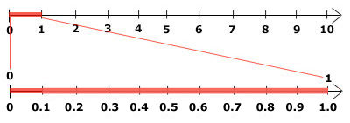

C

B

A

https://encrypted-tbn1.gstatic.com/images?q=tbn:ANd9GcQIBBfXsQlVlC96ZaJRMAdBrTT7BulTs6StuKWusA2oG1qthgXL9Q

A – 0.8

B – 1.9

C – 2.6

* **To find a tenth of an object or quantity you divide by 10**

**3/14 Write a fraction of a number of object**

  

**are blue and are red**

**3/15 Use fractions as numbers**

**To find  of 20 we do 20 ÷ 5 = 4**

**To find  of 20 we do 4 x 2 = 8**

**To find  of 20 we do 4 x 3 = 12**

Example:  of 20 = 20 ÷ 10 = 2

**3/14 Fraction of line or objects**

* **To find  of a line**

**Divide the line into 5 equal parts**

**Each part is **

* **To find  of a set of objects**

**Divide objects into 5 equal parts**





**Each part is **

**3/16 Equivalent fractions**

* The same fraction can be expressed in different ways

ALL THESE ARE 

 =  =  = 

ALL THESE ARE 

 =  =  = 

**3/17 Add & subtract fractions**

* To add and subtract fractions

**When the denominators are the same**

 +  = 

Do not add

the denominators

 -  = 

Do not subtract

the denominators

**3/18 Compare fractions**

* **Fractions with the same denominator**

**   **

|  |  |
| --- | --- |
|  |  |
|  |  |
|  |  |
|  |  |
|  |  |

|  |  |
| --- | --- |
|  |  |
|  |  |
|  |  |
|  |  |
|  |  |

|  |  |
| --- | --- |
|  |  |
|  |  |
|  |  |
|  |  |
|  |  |

|  |  |
| --- | --- |
|  |  |
|  |  |
|  |  |
|  |  |
|  |  |

The bigger the numerator, the bigger the fraction

* **Unit Fractions**

**  **

|  |
| --- |
|  |
|  |

|  |
| --- |
|  |
|  |
|  |

The bigger the denominator, the smaller the fraction

**3/19 Add & subtract measures**

* **The units must be the same**

Length – Example

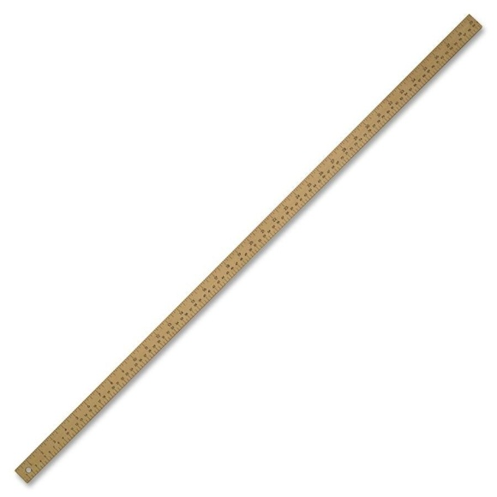

1metre = 100centimetres

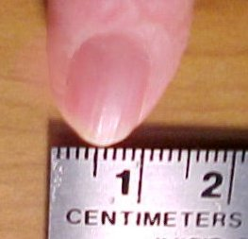

1centimetre = 10millimetres

3cm + 7mm

= 30mm + 7mm

= 37mm

or 3cm 7mm or 3.7cm

**3cm 0.7cm**

|  |
| --- |
|  |
|  |
|  |
|  |
|  |
|  |

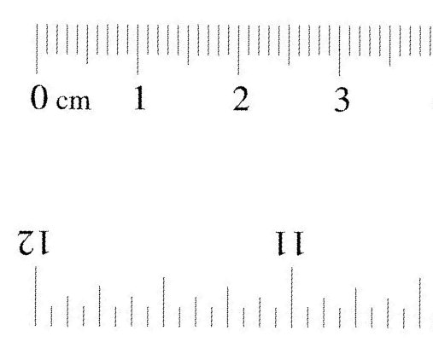

**30mm 7mm**

**Mass – Example**

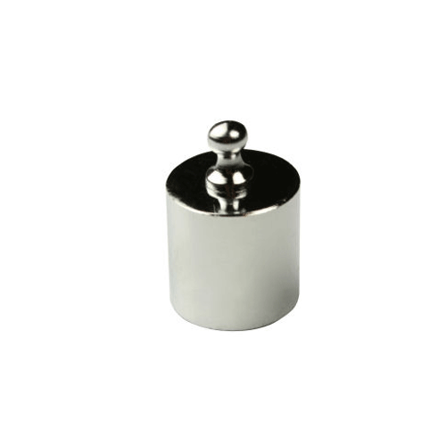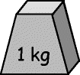

**= 1000g**

3kg – 450g

= 3000g – 450g

= 2550g

or 2kg 550g or 2.55kg

**3/19 Add & subtract measures (continued)**

**Volume – Example**

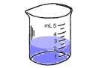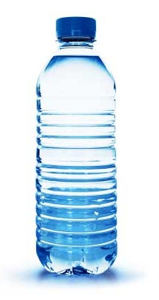

1litre = 1000millilitres

800ml + 720ml

= 1520ml

= 1 litre and 520ml

= 1.52 litres

**3/20 Perimeter**

PERIMETER is the distance round the outside of a shape

* **On a centimetre square grid – count round**

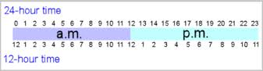

Perimeter of this shape = 12cm

* **Measurements given - add up all round**

6cm

4cm 4cm

6cm

Perimeter of this shape = 6 + 4 + 6 + 4 = 20cm

**3/21 Bills and change**

**To work out a bill**

1 chocolate bar - £1.10

1 pen – 10p

1 pencil – 8p

Total = £1.28

**To find change by the ‘add-on’ method**

+2p +20p +50p = 72p

£1.28 £1.30 £1.50 £2.00

**3/22 Time**

**Analogue clock**

**Roman Hindu-Arabic**

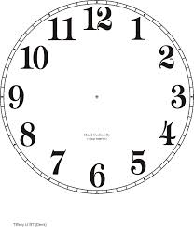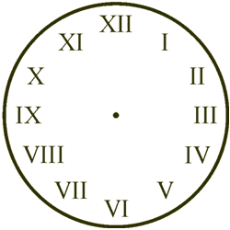

**12- and 24-hour clock**

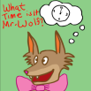**3/23 Time**

**Reading the time**

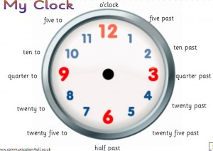

5 minutes between each number- so this time is 1:27 or we say 27 minutes past 1

**Times of the day in 12-hour clock**

|  |  |
| --- | --- |
| **Morning** | **Afternoon** |
| **12.00 midnight** | **12.00**  **noon** |
| 1.00 am | 1.00 pm |
| 2.00 am | 2.00 pm |
| 3.00 am | 3.00 pm |
| 4.00 am | 4.00 pm |
| 5.00 am | 5.00 pm |
| 6.00 am | 6.00 pm |
| 7.00 am | 7.00 pm |
| 8.00 am | 8.00 pm |
| 9.00 am | 9.00 pm |
| 10.00 am | 10.00 pm |
| 11.00 am | 11.00 pm |
| **12.00**  **noon** | **12.00 midnight** |

**3/24 Time – hours minutes, seconds**

÷60

÷60

x60

sec

min

hours

x60

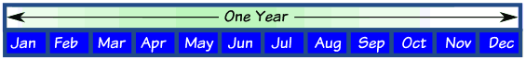**Months of the year**

* A rhyme to remember the days in each month

|  |
| --- |
| *30 days has September, April, June and November. All the rest have 31 Except February alone, Which has 28 days clear And 29 in each leap year.* |

* the "knuckle method"

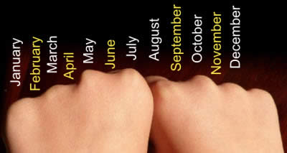A knuckle is "31 days", and in between each knuckle it isn't.  
And where your hands meet, the two knuckles are "July, August", which both have 31 days.

February has 28 days & 29 days in a leap year (every 4 years)

**Days in a year**

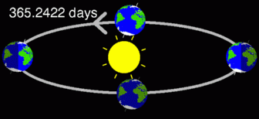

**365 days in a year**

**366 days in a leap year**

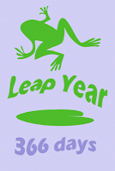

**3/25 – 2D Shapes**

* **With 3 sides (Triangles)**

A

B

C

D

**right-angled isosceles equilateral scalene**

* **With 4 sides (Quadrilaterals)**

A

B

C

D

E

**square rectangle parallelogram trapezium rhombus**

* **With 5 sides (Pentagons) With 6 sides (Hexagons)**

**regular irregular regular irregular**

**3/25 – 3D Shapes**

Cube cuboid triangular prism cylinder sphere cone square-based

Pyramid

* **Nets**

**3/26 Angle**

* **An angle is an amount of turn**

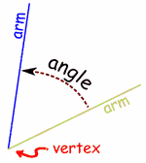

* **Angles in shapes**

**Triangle - 3 angles**

**Quadrilateral - 4 angles**

**Pentagon – 5 angles**

* **Names of angles**

**ACUTE angles are less than 900**

**RIGHT angles are exactly 900**

**A square for 900 angle**

**OBTUSE angles are bigger than 900**

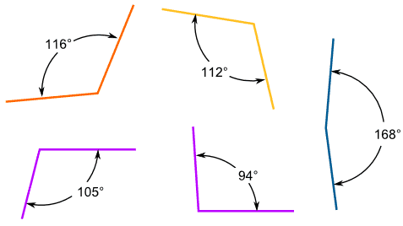

**3/27 Right angles**

ONE right angle measures exactly 900

TWO right angles measure exactly 1800

This is called a half-turn

THREE right angles measure exactly 2700

This is called three quarters of a turn

FOUR right angles measure exactly 3600

This is called a full or complete turn

**To check if an angle is bigger or smaller than a right angle, use a square corner**

This angle is greater This angle is less

than a right angle than a right angle

**3/28 Types of Lines**



**The Horizon is a horizontal line**

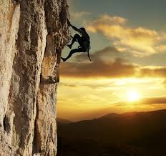

**This cliff face is a vertical line**

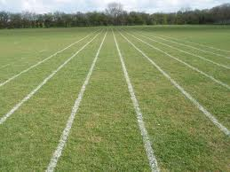

**The running track is parallel lines (never meet)**

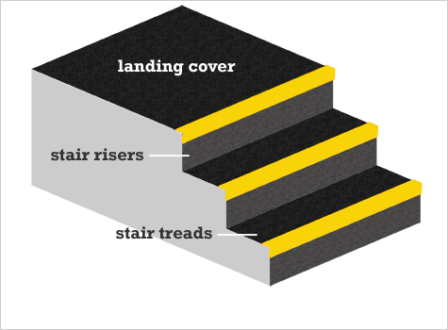

**The rise & tread are perpendicular lines (meet at 900)**

**3/29 Bar charts**

Frequency table to show pets owned by Year 3

|  |  |  |
| --- | --- | --- |
| Type of pet | Tally | Number of pets |
| **Dog** | **llll** | **5** |
| **Cat** | **lll** | **3** |
| **Rabbit** | **llll** | **4** |
| **Fish** | **llll lll** | **8** |
| **Hamster** | **ll** | **2** |

A bar graph to show pets owned by Year 3

Number of children

Type of pet

Pictogram to show the colours in a tube of Smarties

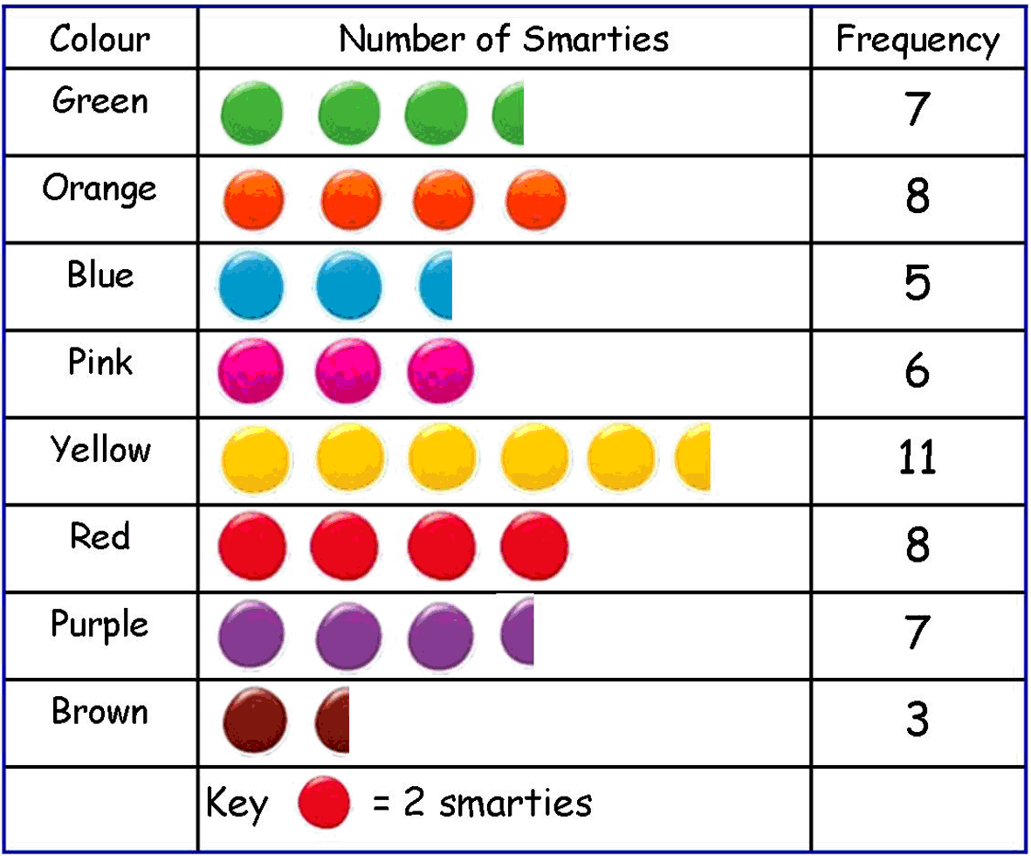

**3/30 Solve answers to questions**

* **Bar chart in 3/29**

1. How many **more** children own a rabbit than a hamster?

Answer: 4-2 = 2

1. What is the **difference** between the number of children who own a dog and the number of children who own a cat?

Answer: 5 – 3 = 2

1. How many pets are owned **altogether** by the children Year 3?

Answer: 5 + 3 + 4 + 8 + 2 = 22

* **Pictogram in 3/29**

1. How many **fewer** blue smarties are there than yellow ones?

Answer: 11 – 5 = 6

1. Work out the **total** number of smarties in the tube

Answer: 55